Plane and Plane

Definition
# Source: AI Source: Provided by: [Data Path: Persons Table -> ID Column: 1, Name_En Column: Motasem Essam] -> From: [ChatGPT] on [7/25/2026]
The relationship between two planes in solid geometry describes how two flat surfaces are positioned relative to each other in three-dimensional space.
Two planes can have three fundamental relationships:
- Intersecting planes: The planes meet along a straight line.
- Parallel planes: The planes never meet and remain a constant positive distance apart.
- Coincident planes: The planes occupy exactly the same position and share every point.
Perpendicular planes are a special type of intersecting planes that meet at an angle of ${90}^{∘}$.
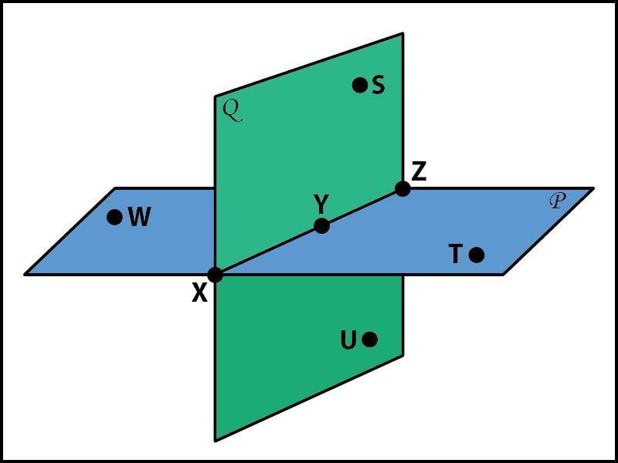
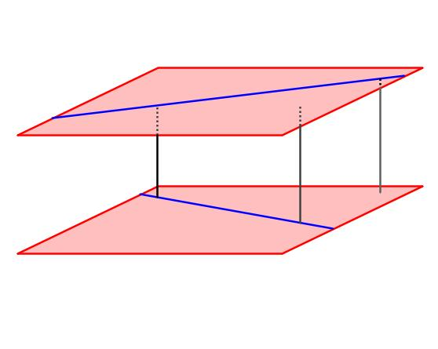
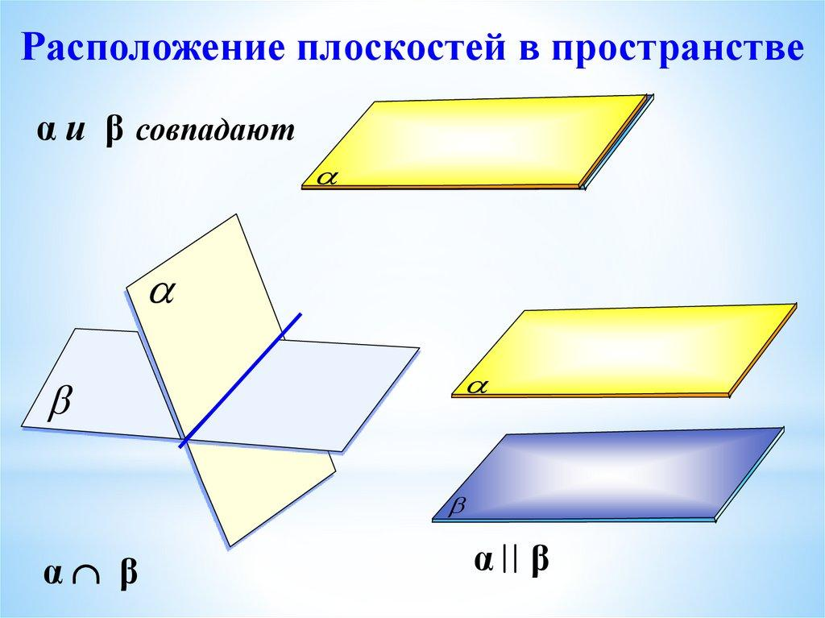

Simple Definition
# Source: AI Source: Provided by: [Data Path: Persons Table -> ID Column: 1, Name_En Column: Motasem Essam] -> From: [ChatGPT] on [7/25/2026]
The relationship between two planes tells us whether they cross each other, remain separate, or occupy the same location.
Examples include:
- Intersecting planes: Two adjacent walls meeting along an edge.
- Parallel planes: The floor and ceiling of a rectangular room.
- Coincident planes: Two equations describing exactly the same flat surface.
- Perpendicular planes: A vertical wall and a horizontal floor meeting at a right angle.
These examples represent ideal mathematical planes, which extend infinitely in all directions within their surfaces.

Types of Relationships Between Two Planes

1. Intersecting Planes
# Source: AI Source: Provided by: [Data Path: Persons Table -> ID Column: 1, Name_En Column: Motasem Essam] -> From: [ChatGPT] on [7/25/2026]
Two distinct planes that share exactly one straight line.
$$P_{1}∩P_{2}=L$$
Their normal vectors are not proportional.
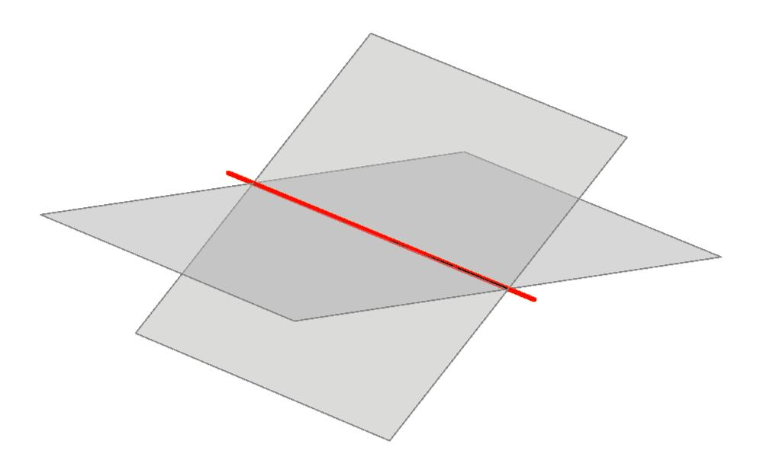

2. Parallel Planes
# Source: AI Source: Provided by: [Data Path: Persons Table -> ID Column: 1, Name_En Column: Motasem Essam] -> From: [ChatGPT] on [7/25/2026]
Two distinct planes that never intersect and maintain a constant positive perpendicular distance.
$$P_{1}∩P_{2}=∅$$
Their normal vectors are proportional.
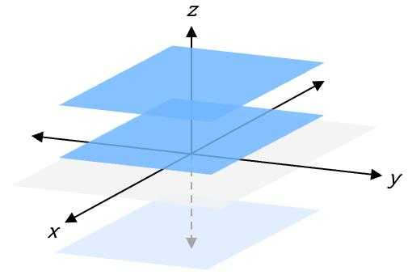

3. Coincident Planes
# Source: AI Source: Provided by: [Data Path: Persons Table -> ID Column: 1, Name_En Column: Motasem Essam] -> From: [ChatGPT] on [7/25/2026]
Two plane equations that represent the same geometric plane.
$$P_{1}=P_{2}$$
Every point on one plane belongs to the other.

4. Perpendicular Planes
# Source: AI Source: Provided by: [Data Path: Persons Table -> ID Column: 1, Name_En Column: Motasem Essam] -> From: [ChatGPT] on [7/25/2026]
Two intersecting planes whose angle is ${90}^{∘}$.
$$P_{1}⊥P_{2}$$
Their normal vectors are perpendicular.
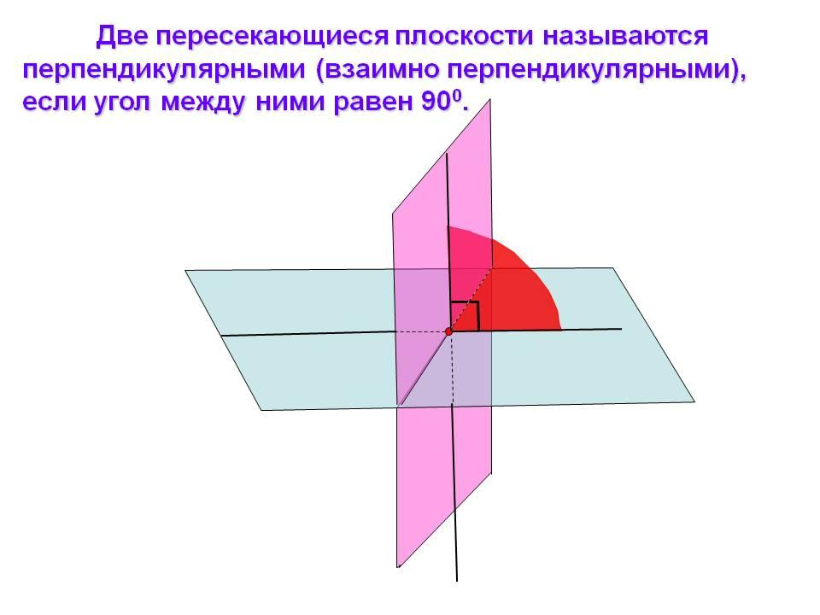

Key Characteristics
# Source: AI Source: Provided by: [Data Path: Persons Table -> ID Column: 1, Name_En Column: Motasem Essam] -> From: [ChatGPT] on [7/25/2026]
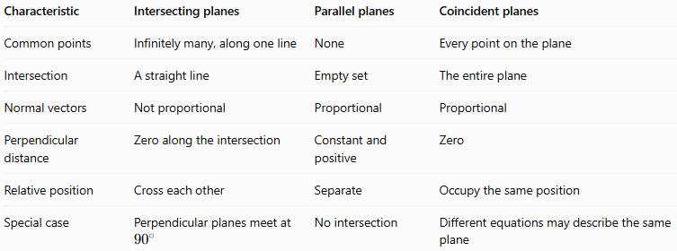
Characteristic | Intersecting planes | Parallel planes | Coincident planes
Common points | Infinitely many, along one line | None | Every point on the plane
Intersection | A straight line | Empty set | The entire plane
Normal vectors | Not proportional | Proportional | Proportional
Perpendicular distance | Zero along the intersection | Constant and positive | Zero
Relative position | Cross each other | Separate | Occupy the same position
Special case | Perpendicular planes meet at ${90}^{∘}$ | No intersection | Different equations may describe the same plane

Mathematical Representation

General equations of two planes
# Source: AI Source: Provided by: [Data Path: Persons Table -> ID Column: 1, Name_En Column: Motasem Essam] -> From: [ChatGPT] on [7/25/2026]
In three-dimensional Cartesian coordinates, two planes can be represented as
$$P_{1}:A_{1}x+B_{1}y+C_{1}z+D_{1}=0$$
$$P_{2}:A_{2}x+B_{2}y+C_{2}z+D_{2}=0$$
Their normal vectors are
$$n_{1}=\left(A_{1},B_{1},C_{1}\right)$$
$$n_{2}=\left(A_{2},B_{2},C_{2}\right)$$
The relationship between the planes can be determined by comparing these normal vectors and their constant terms.

Condition for intersecting planes
# Source: AI Source: Provided by: [Data Path: Persons Table -> ID Column: 1, Name_En Column: Motasem Essam] -> From: [ChatGPT] on [7/25/2026]
Two distinct planes intersect along a straight line when their normal vectors are not proportional.
$$\boxed{n_{1}×n_{2}≠0}$$
The cross product gives a direction vector for the line of intersection.
If the planes are perpendicular, their normal vectors also satisfy
$$\boxed{n_{1}⋅n_{2}=0}$$

Condition for parallel planes
# Source: AI Source: Provided by: [Data Path: Persons Table -> ID Column: 1, Name_En Column: Motasem Essam] -> From: [ChatGPT] on [7/25/2026]
Two planes are parallel or coincident if their normal vectors are proportional:
$$\boxed{n_{2}=kn_{1}}$$
where $k≠0$.
To distinguish parallel planes from coincident planes, check whether all four coefficients are proportional by the same factor.
For example,
$$P_{1}:2x+3y+z-4=0$$
$$P_{2}:4x+6y+2z+10=0$$
The normal vectors are proportional, but multiplying the first equation by $2$ gives a constant term of $-8$, not $+10$. Therefore, the planes are distinct and parallel.

Condition for coincident planes
# Source: AI Source: Provided by: [Data Path: Persons Table -> ID Column: 1, Name_En Column: Motasem Essam] -> From: [ChatGPT] on [7/25/2026]
The planes are coincident if there exists a nonzero constant $k$ such that
$$\boxed{\begin{aligned}A_{2}&=kA_{1} \\ B_{2}&=kB_{1} \\ C_{2}&=kC_{1} \\ D_{2}&=kD_{1}\end{aligned}}$$
This means one complete plane equation is a nonzero scalar multiple of the other.

Angle between two planes
# Source: AI Source: Provided by: [Data Path: Persons Table -> ID Column: 1, Name_En Column: Motasem Essam] -> From: [ChatGPT] on [7/25/2026]
The smaller angle $θ$ between two planes can be calculated using their normal vectors:
$$\boxed{θ=\cos^{-1}\left(\frac{\left|n_{1}⋅n_{2}\right|}{\left\|n_{1}\right\|\left\|n_{2}\right\|}\right)}$$
- If $θ={90}^{∘}$, the planes are perpendicular.
- If $0^{∘}<θ<{90}^{∘}$, they intersect obliquely.
- If $θ=0^{∘}$, their normal directions are parallel, so the planes are either distinct and parallel or coincident.

Worked Examples
# Source: AI Source: Provided by: [Data Path: Persons Table -> ID Column: 1, Name_En Column: Motasem Essam] -> From: [ChatGPT] on [7/25/2026]
Example 1: Determine whether two planes intersect
Consider
$$P_{1}:x+y+z=6$$
$$P_{2}:x-y+z=2$$
Step 1: Find the normal vectors.
$$n_{1}=\left(1,1,1\right)$$
$$n_{2}=\left(1,-1,1\right)$$
These vectors are not proportional, so the planes intersect along a straight line.
Step 2: Find the intersection line.
Subtract the second equation from the first:
$$2y=4⟹y=2$$
Substitute into the first equation:
$$x+z=4$$
Let $x=t$, giving $z=4-t$.
Therefore, the intersection line is
$$\boxed{\left(x,y,z\right)=\left(t,2,4-t\right)}$$
Example 2: Determine whether two planes are parallel
Consider
$$P_{1}:2x+3y+z-4=0$$
$$P_{2}:4x+6y+2z+10=0$$
The normal vectors are
$$n_{1}=\left(2,3,1\right)$$
$$n_{2}=\left(4,6,2\right)=2n_{1}$$
Their normal vectors are proportional.
However, multiplying the first equation by $2$ gives
$$4x+6y+2z-8=0$$
This is not the second equation. Therefore, the planes are distinct and parallel.
Example 3: Determine whether two planes are coincident
Consider
$$P_{1}:x+2y+3z-5=0$$
$$P_{2}:3x+6y+9z-15=0$$
Multiplying the first equation by $3$ produces the second equation exactly.
Thus,
$$\boxed{P_{1}=P_{2}}$$
The planes are coincident.
Example 4: Determine whether two planes are perpendicular
Consider
$$P_{1}:x+y=0$$
$$P_{2}:x-y=0$$
Their normal vectors are
$$n_{1}=\left(1,1,0\right)$$
$$n_{2}=\left(1,-1,0\right)$$
Calculate the dot product:
$$n_{1}⋅n_{2}=1\left(1\right)+1\left(-1\right)+0\left(0\right)=0$$
Therefore, the planes are perpendicular.
Their intersection satisfies $x=0$ and $y=0$, while $z$ is unrestricted. Their intersection is the $z$-axis.

Comparison with Related Concepts
# Source: AI Source: Provided by: [Data Path: Persons Table -> ID Column: 1, Name_En Column: Motasem Essam] -> From: [ChatGPT] on [7/25/2026]
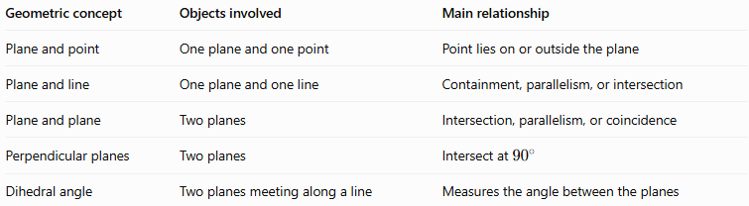
Geometric concept | Objects involved | Main relationship
Plane and point | One plane and one point | Point lies on or outside the plane
Plane and line | One plane and one line | Containment, parallelism, or intersection
Plane and plane | Two planes | Intersection, parallelism, or coincidence
Perpendicular planes | Two planes | Intersect at ${90}^{∘}$
Dihedral angle | Two planes meeting along a line | Measures the angle between the planes

Applications
# Source: AI Source: Provided by: [Data Path: Persons Table -> ID Column: 1, Name_En Column: Motasem Essam] -> From: [ChatGPT] on [7/25/2026]
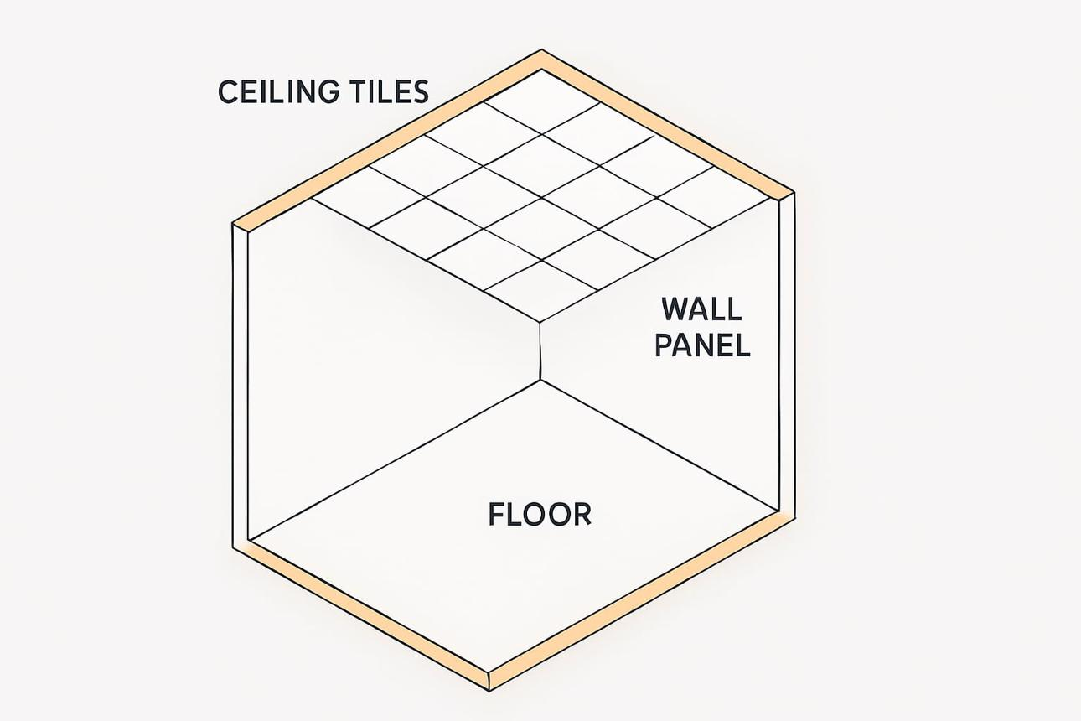
Architecture and construction
Floors, ceilings, and walls can be modeled as planes to determine whether surfaces are parallel, perpendicular, or intersecting.
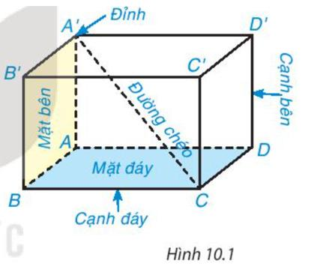
Three-dimensional geometry
The faces of cubes and rectangular cuboids illustrate parallel and perpendicular planes.
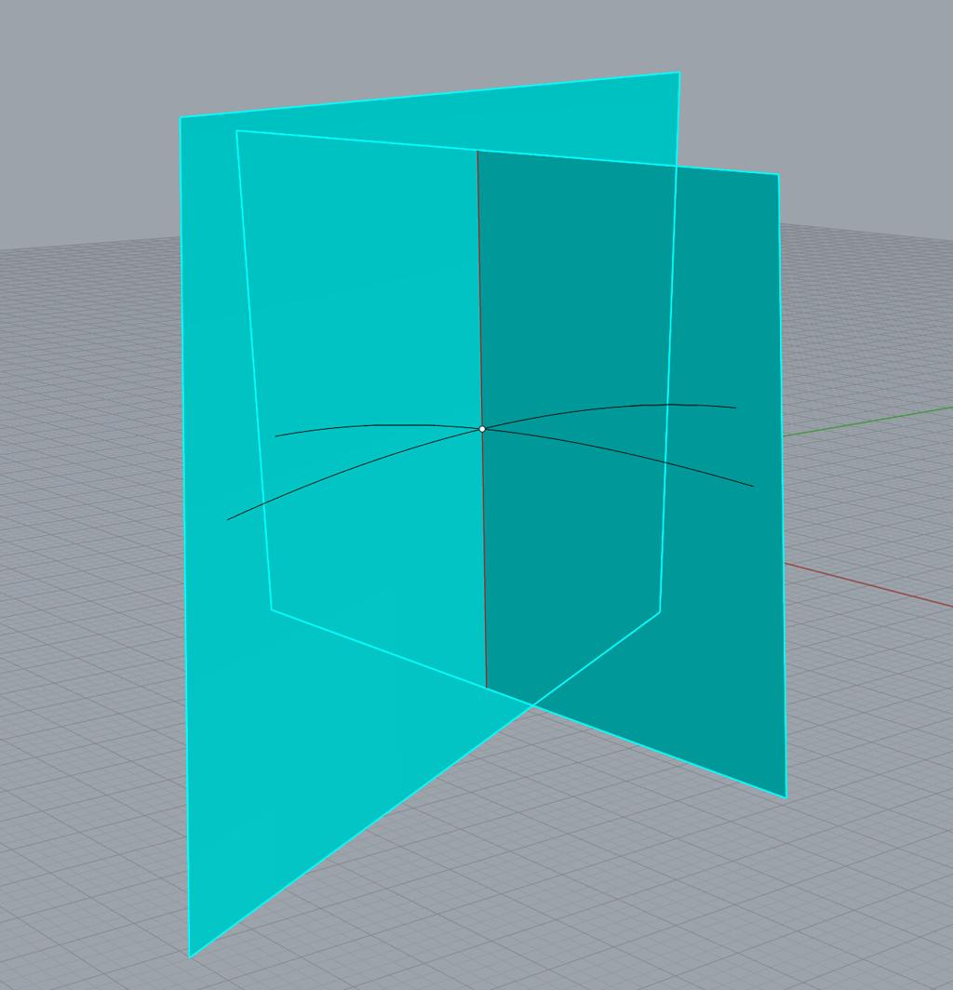
Computer graphics and CAD
Plane relationships help calculate intersections, define reference surfaces, and detect overlapping geometric objects.

Key Points
# Source: AI Source: Provided by: [Data Path: Persons Table -> ID Column: 1, Name_En Column: Motasem Essam] -> From: [ChatGPT] on [7/25/2026]
- Two distinct nonparallel planes intersect along exactly one straight line.
- Two distinct parallel planes have no common points.
- Coincident planes represent the same geometric plane.
- Perpendicular planes are intersecting planes with a ${90}^{∘}$ angle.
- Normal vectors determine the orientation of each plane.
- Proportional normal vectors alone do not distinguish parallel planes from coincident planes; the constant terms must also be checked.
- The dot product determines whether intersecting planes are perpendicular.

Conclusion
# Source: AI Source: Provided by: [Data Path: Persons Table -> ID Column: 1, Name_En Column: Motasem Essam] -> From: [ChatGPT] on [7/25/2026]
The relationship between two planes describes their relative positions and orientations in three-dimensional space. By using plane equations, normal vectors, dot products, and cross products, we can determine whether two planes intersect, remain parallel, coincide, or meet perpendicularly. These relationships form an important foundation for understanding solid geometry and three-dimensional coordinate geometry.

